**Lab Sheet 1**

1. WAP to display hello world.

* **Objective**

The objective of this program is to write a code that displays the message "Hello, World!" on the console.

* **Algorithm**

1. Start
2. Display "Hello, World!"
3. Stop

* **Flowchart**

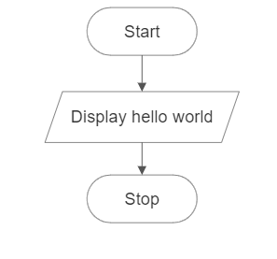

* **Code**

#include <stdio.h>

int main( ) {

printf("Hello, World!\n");

return 0;

}

* **Output**

Hello, World!

* **Discussion and Conclusion**

This program displays the message "Hello, World!" on the console. The printf function is used to print the message. The \n is used to add a new line after the message. The program was implemented using the VS Code IDE and compiled using gcc to generate an executable file.

1. WAP to display your name, roll number and address

* **Objective**

The objective of this program is to write a code that displays your name, roll number, and address on the console.

* **Algorithm**

1. Start
2. Display name, roll number and address
3. Stop

* **Flowchart**

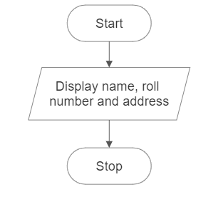

* **Code**

#include <stdio.h>

int main( )

{

    printf("Name: Tilak Thapa\n");

    printf("Roll Number: PUR079BCT094\n");

    printf("Address: Tulsipur - 4, Dang\n");

    return 0;

}

* **Output**

Name: Tilak Thapa

Roll Number: PUR079BCT094

Address: Tulsipur - 4, Dang

* **Discussion and Conclusion**

This program displays my name, roll number, and address on the console. The printf function is used to print each piece of information. The newline character \n is used to add a new line after each line of output. The program was implemented using the VS Code IDE and compiled using gcc to generate an executable file.

1. WAP to add two integer variables and print sum

* **Objective**

The objective of this program is to write a code that adds two predefined integer variables and prints their sum.

* **Algorithm**

1. Start.
2. Declare two integer variables, num1 and num2, and initialize them with predefined values.
3. Calculate the sum of num1 and num2 and store it in a variable called sum.
4. Print the value of sum.
5. Stop.

* **Flowchart**

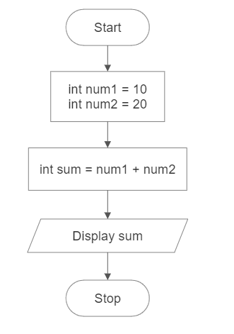

* **Code**

#include <stdio.h>

int main( )

{

int num1 = 10;

int num2 = 20;

int sum = num1 + num2;

printf("Sum: %d\n", sum);

return 0;

}

* **Output**

Sum: 30

* **Discussion and Conclusion**

This program adds two predefined integer variables, num1 and num2, and prints their sum. The values of num1 and num2 are initialized with the numbers 10 and 20, respectively. The sum of num1 and num2 is calculated and stored in the sum variable using the addition operator (+). The printf function is used to display the value of sum. The program was implemented using the VS Code IDE and compiled using gcc to generate an executable file. The objective of the program was achieved, and the code executed successfully.

1. WAP to multiply two integer variables and print product

* **Objective**

The objective of this program is to write a code that multiplies two integer variables and prints their product.

* **Algorithm**

1. Start.
2. Declare two integer variables, num1 and num2, and initialize them with predefined values.
3. Calculate the product of num1 and num2 and store it in a variable called product.
4. Print the value of product.
5. Stop.

* **Flowchart**

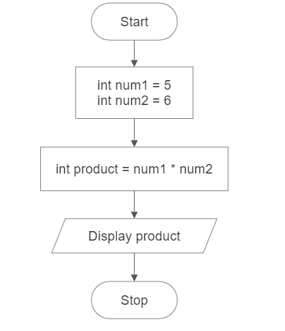

* **Code**

#include <stdio.h>

int main()

{

int num1 = 5;

int num2 = 6;

int product = num1 * num2;

printf("Product: %d\n", product);

return 0;

}

* **Output**

Product: 30

* **Discussion and Conclusion**

This program multiplies two integer variables, num1 and num2, and prints their product. The values of num1 and num2 are assigned as 5 and 6, respectively. The product of num1 and num2 is calculated and stored in the product variable using the multiplication operator (*). The printf function is used to display the value of product. The program was implemented using the VS Code IDE and compiled using gcc to generate an executable file. The objective of the program was achieved, and the code executed successfully.

1. WAP to calculate and display the simple interest.

* **Objective**

The objective of this program is to write a code that calculates and displays the simple interest based on predefined values for principal amount, rate, and time.

* **Algorithm**

1. Start.
2. Declare and initialize three variables: principal, rate, and time with predefined values.
3. Calculate the simple interest using the formula: interest = (principal * rate * time) / 100 and assign the value to variable called interest.
4. Print the value of the interest.
5. Stop.

* **Flowchart**

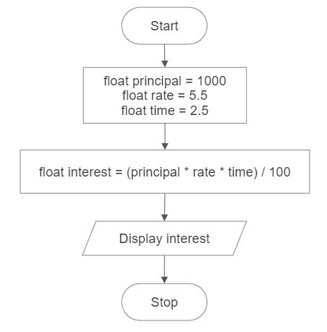

* **Code**

#include <stdio.h>

int main()

{

float principal = 1000;

float rate = 5.5;

float time = 2.5;

float interest = (principal * rate * time) / 100;

printf("Simple Interest: Rs %f\n", interest);

return 0;

}

* **Output**

Interest: Rs 137.500000

* **Discussion and Conclusion**

This program calculates and displays the simple interest based on predefined values for the principal amount, rate of interest, and time period. The values of principal, rate, and time are initialized as 1000, 5.5, and 2.5, respectively. The simple interest is calculated using the formula: interest = (principal * rate * time) / 100. The calculated interest value is then printed using the printf function. The program was implemented using the VS Code IDE and compiled using gcc to generate an executable file.

1. WAP to calculate the area of the circle

* **Objective**

The objective of this program is to write a code that calculates the area of a circle based on a predefined radius.

* **Algorithm**

1. Start.
2. Declare a constant variable for PI and a variable for the radius and assign their values.
3. Calculate the area of the circle using the formula: area = pi * radius * radius and assign the value to a variable called area.
4. Print the value of the area.
5. Stop.

* **Flowchart**

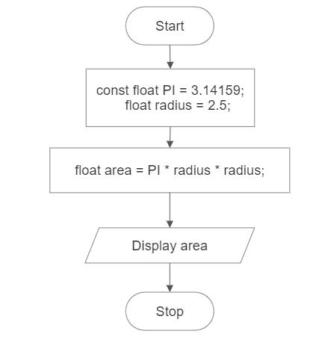

* **Code**

#include <stdio.h>

int main( )

{

const float PI = 3.14159;

float radius = 2.5;

float area = PI * radius * radius;

printf("Area of the circle: %.2f sq unit.\n", area);

return 0;

}

* **Output**

Area of the circle: 19.63 sq unit.

* **Discussion and Conclusion:**

This program calculates the area of a circle based on a predefined radius. The value of radius is assigned as 2.5. The area of the circle is calculated using the formula: area = PI * radius * radius, where PI is a constant value representing the mathematical constant pi (approximately 3.14159). The calculated area value is then printed using the printf function. The program was implemented using the VS Code IDE and compiled using gcc to generate an executable file